CHAROTAR UNIVERSITY OF SCIENCE AND TECHNOLOGY
FACULTY OF TECHNOLOGY AND ENGINEERING
CHANDUBHAI S. PATEL INSTITUTE OF TECHNOLOGY
OCCE4001 - SOFTWARE TESTING

PRACTICAL LIST – AY: 2026- 27
Sr. no. | Title | CO/PO
 | Title: API Testing using Postman  Aim: To perform functional testing of REST APIs by validating requests, responses, status codes, headers, and response time using Postman.  Software/Tools Required  - Postman  - Web Browser  - Internet Connection  - Public REST API (e.g., JSON Placeholder)  Procedure  - Install and launch Postman.  - Send a GET request to retrieve data from a REST API.  - Send a POST request with sample JSON data.  - Validate the HTTP status code.  - Verify the response body and headers.  - Measure the response time.  - Save the requests in a Postman Collection.  - Record the observations.  Expected Outcome: REST APIs are successfully validated for functionality and correctness.  Result: Test and validated API calls | CO4 / PO1, PO2, PO3, PO5 and PO12
Solution:
- Install and open Postman or signup for https://www.postman.com/
- Then create a new HTTP request
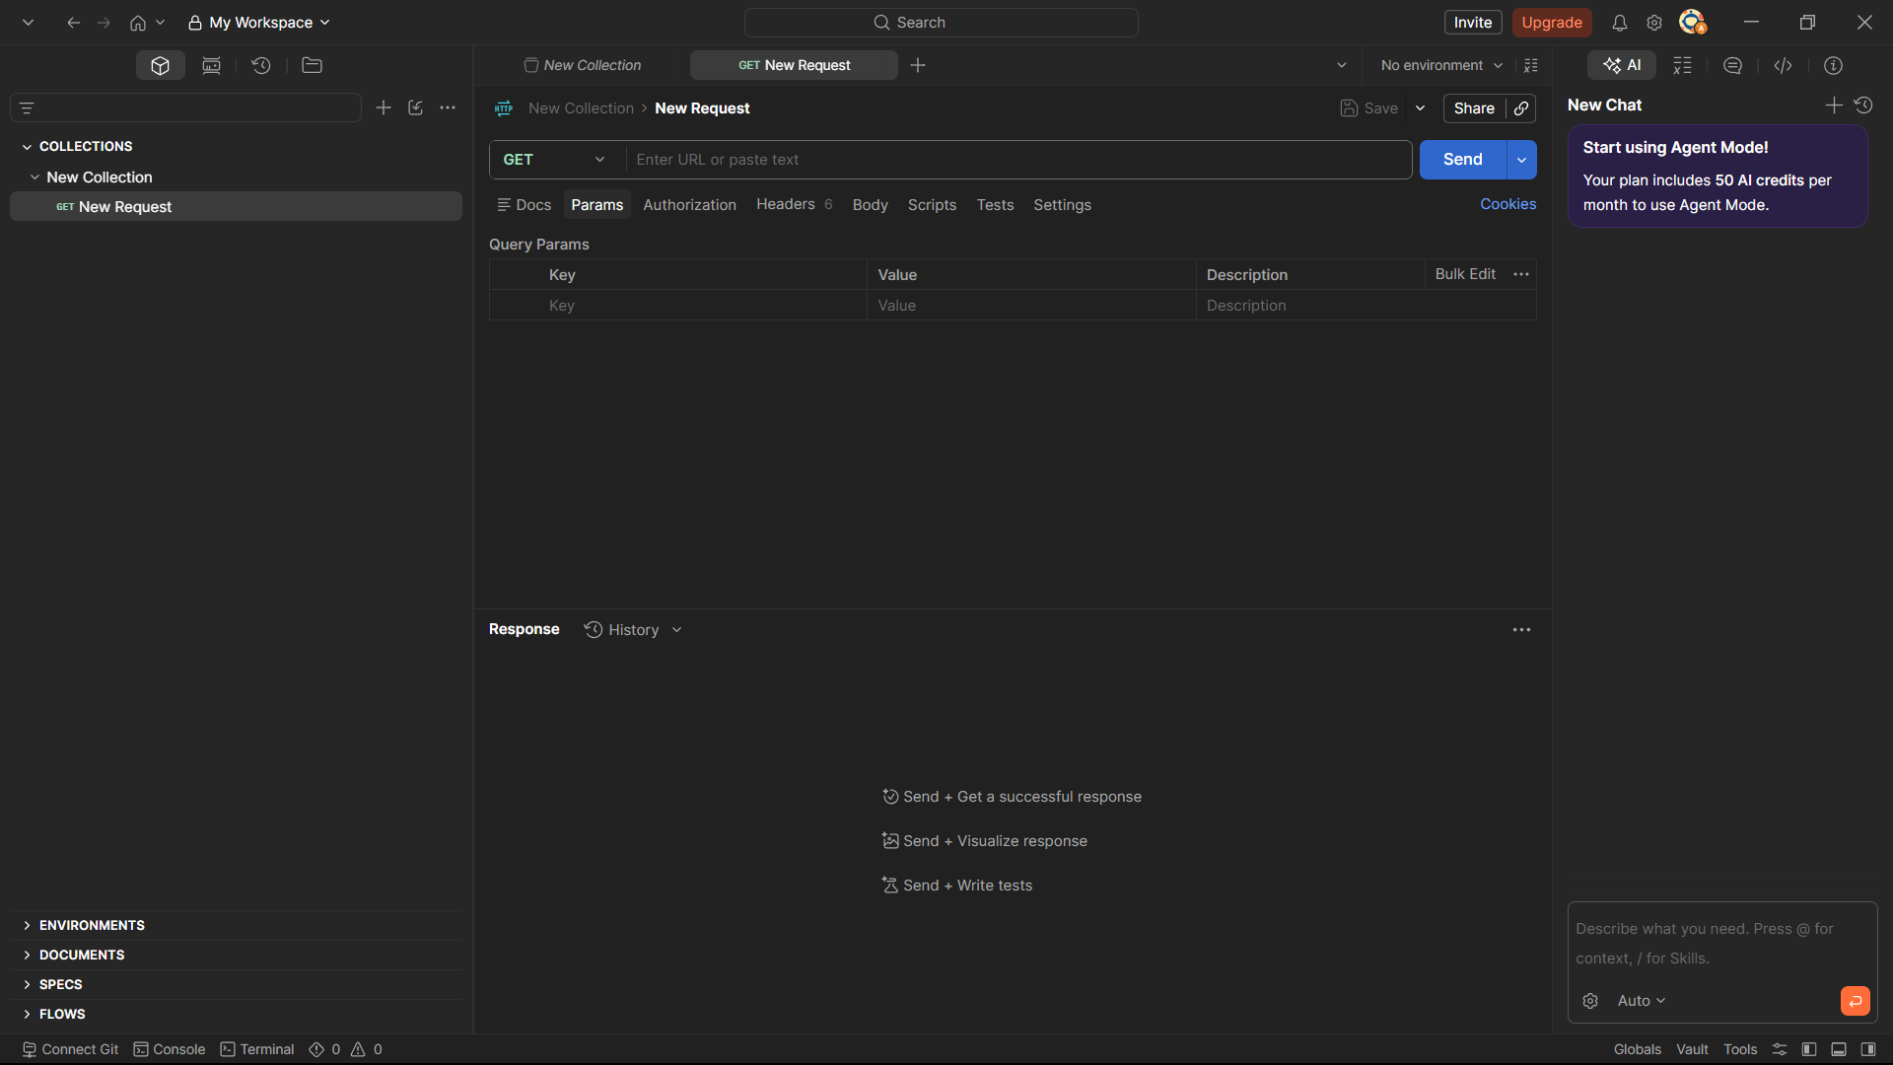
- Send a GET request to https://jsonplaceholder.typicode.com/posts/1 and verify the response data and 200 OK status code.
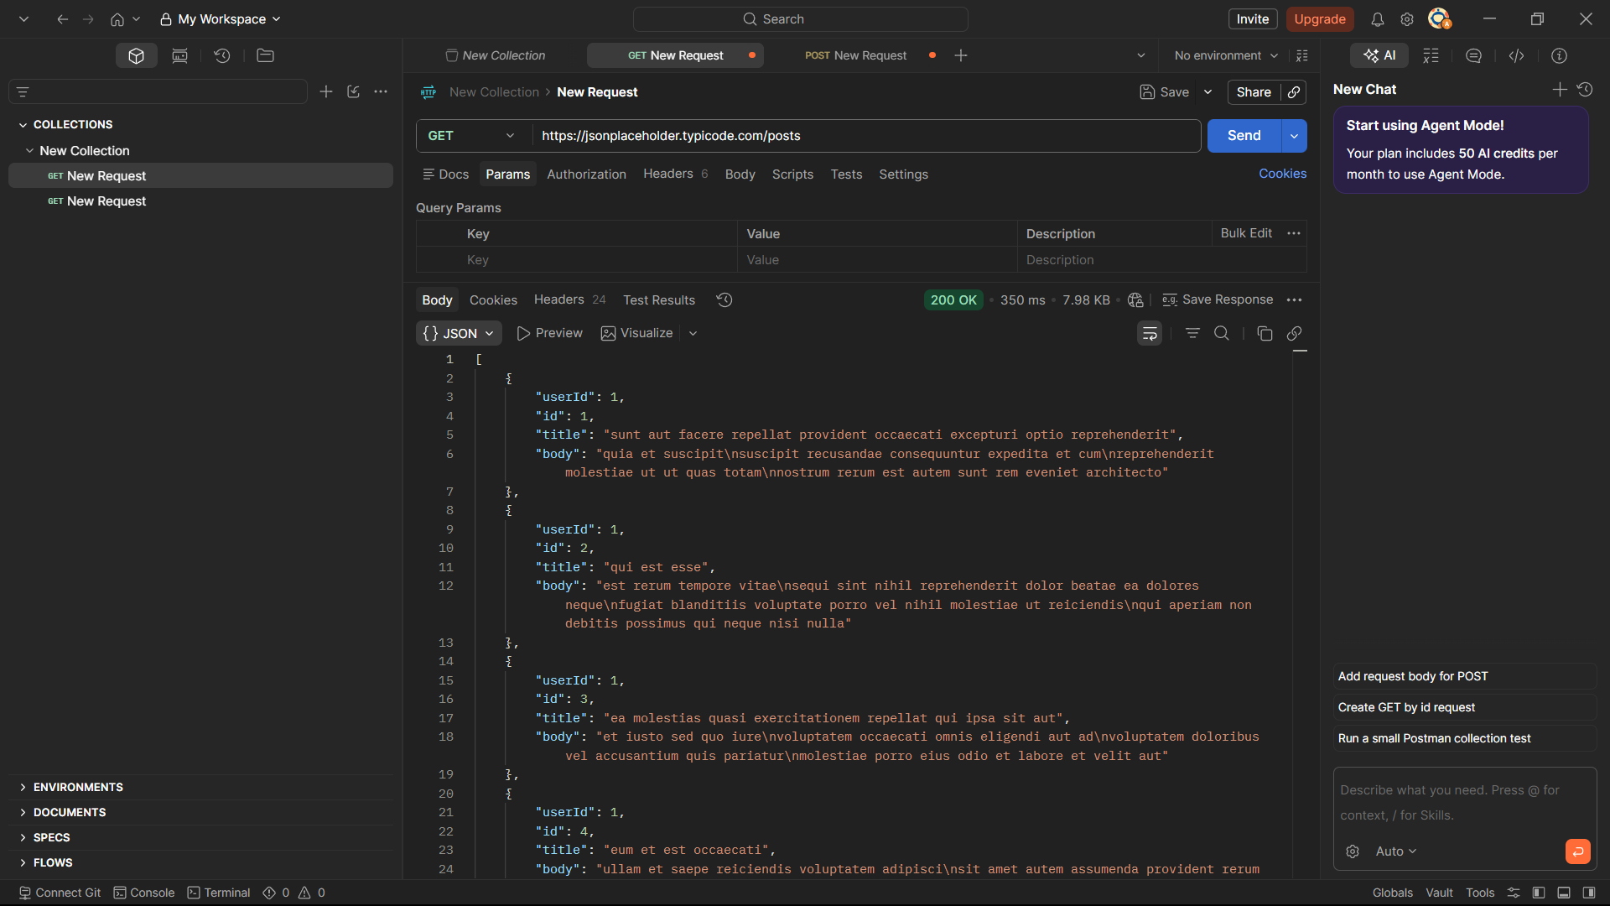

- Create a POST request, enter sample JSON data in the request body, and send the request.
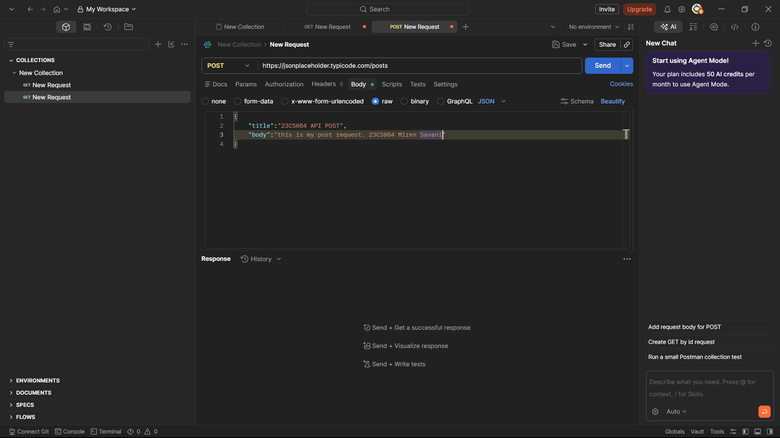
- Verify that the response returns the created data with the 201 Created status code.
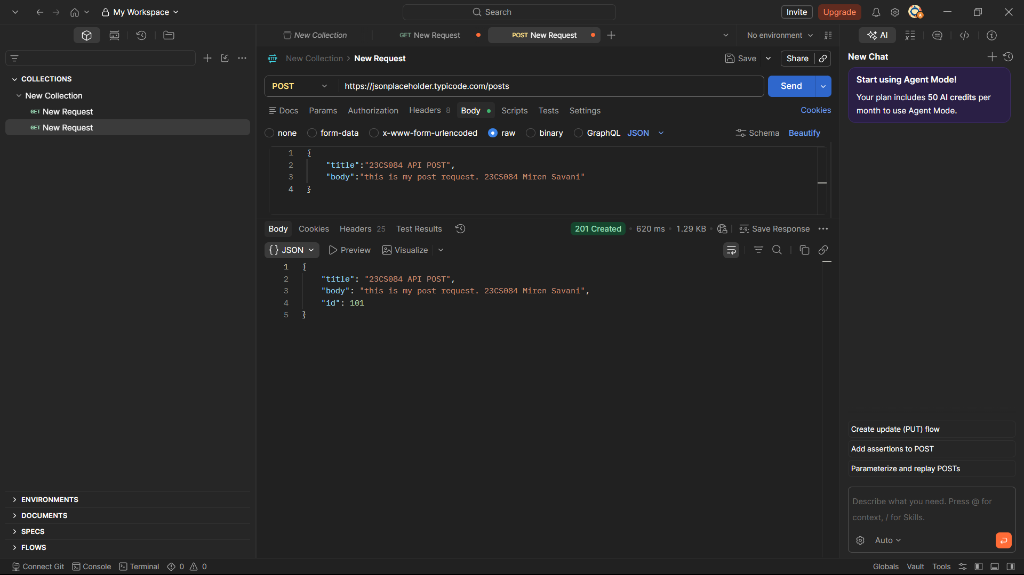

- Check the response headers, response body, and response time for both requests.
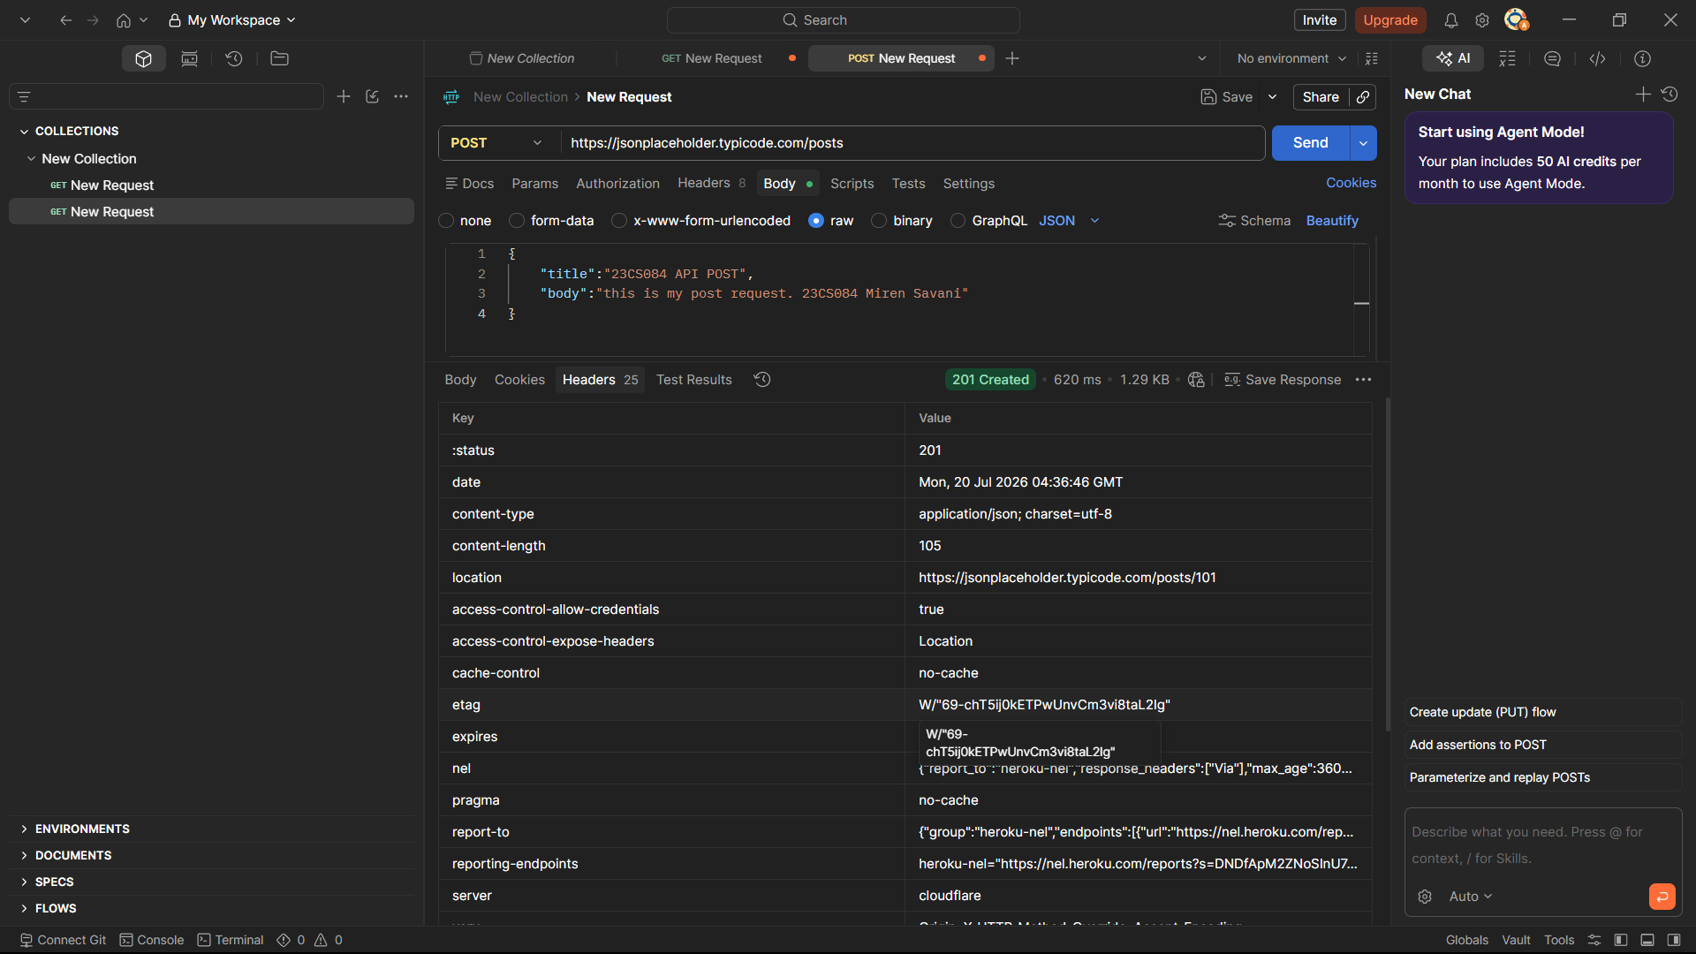
- Save the requests in a Postman Collection and record the observations and results.
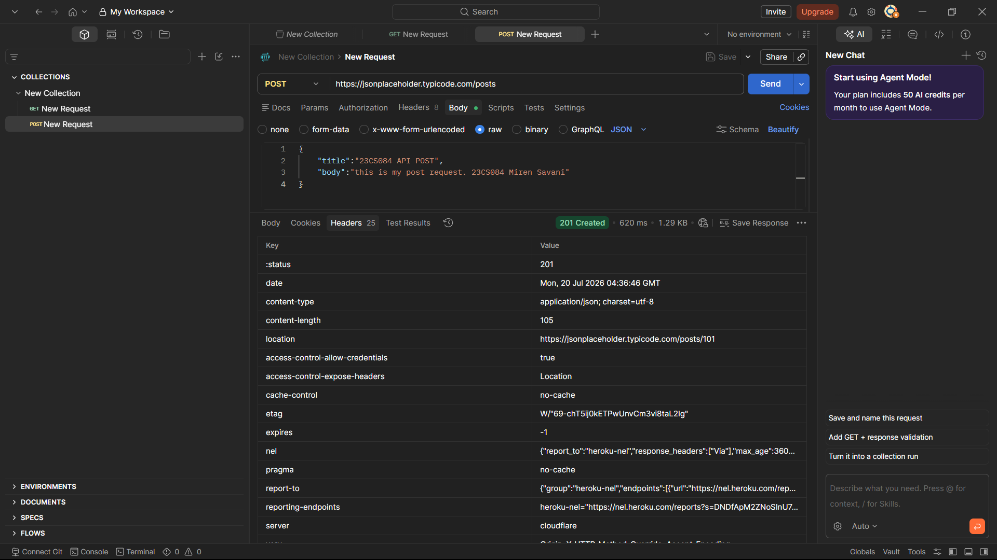
Reference Youtube Video:
https://www.youtube.com/watch?v=wEOLZq-7DYs

